Chart 1

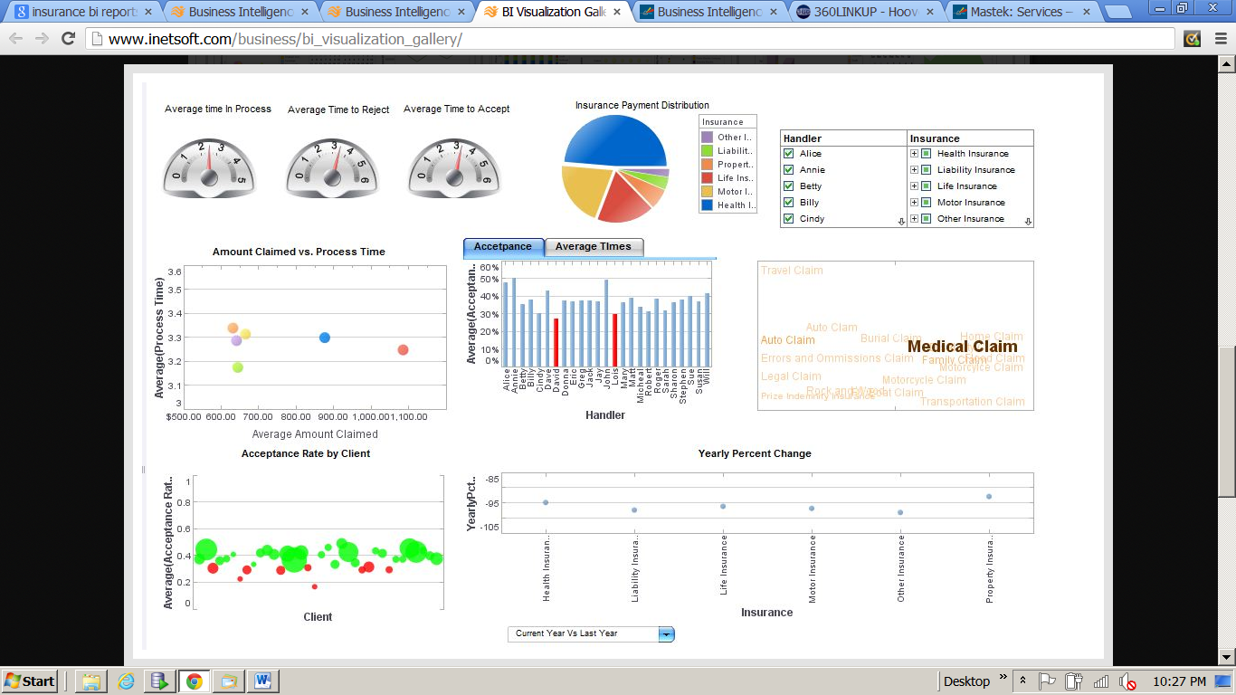

Average Time take for processing:

This should also show the standard TAT time against two process i.e. Processing time and Approval time.

Chart 2

Sub Product Break-up:



Give an option to choose main product n Sub Products



Chart 3



Provide option for choosing Product (same as above)

Chart 4



Text Analysis/ cloud for most trending sub product…allow to choose Product.

Chart 5



Total amount claimed for each subproduct.

Data for the above Chart is in the excel file.